**Class:** Final Year (Computer Science and Engineering)

**Year:** 2022-23 **Semester:** 1

**Course:** High Performance Computing Lab

**Practical No. 9**

**Exam Seat No:**

2019BTECS00037 – Onkar Gavali

**Title of practical:**

Implementation of Vector-Vector addition & N-Body Simulator using CUDA C

**Problem Statement 1:**

Implement Vector-Vector addition using CUDA C. State and justify the speedup using different size of threads and blocks.

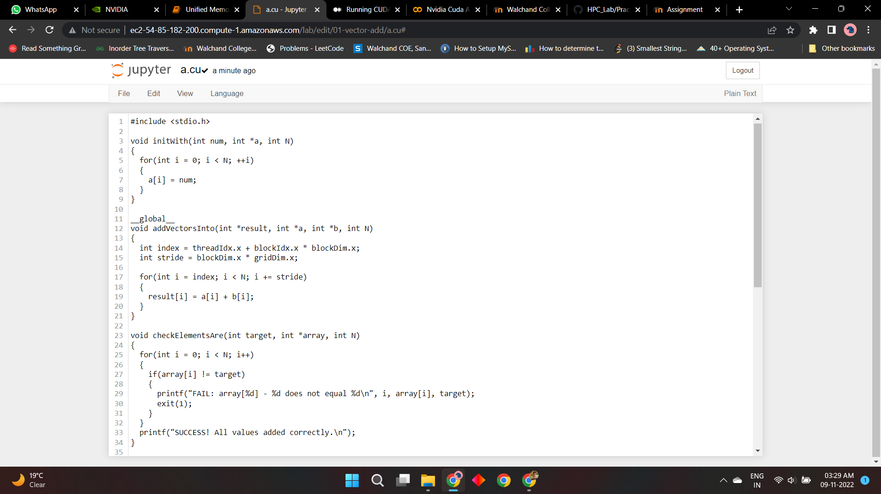

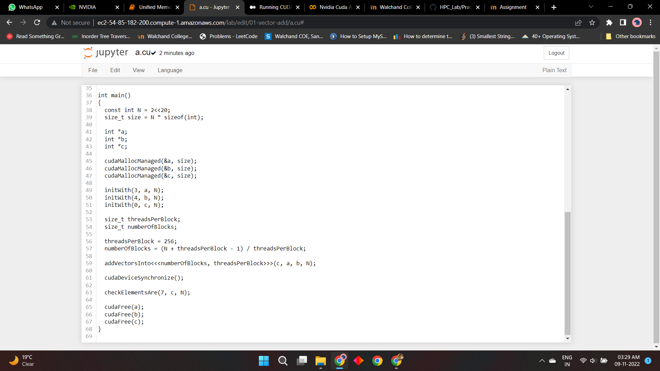

**Answer:**

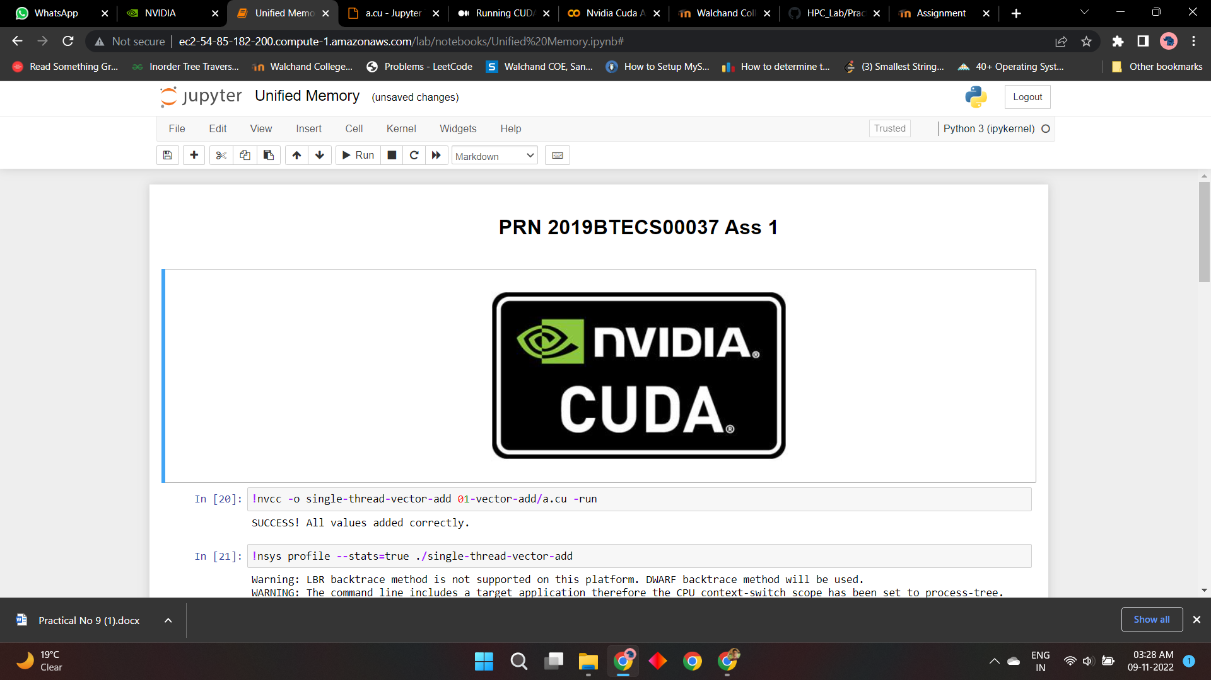

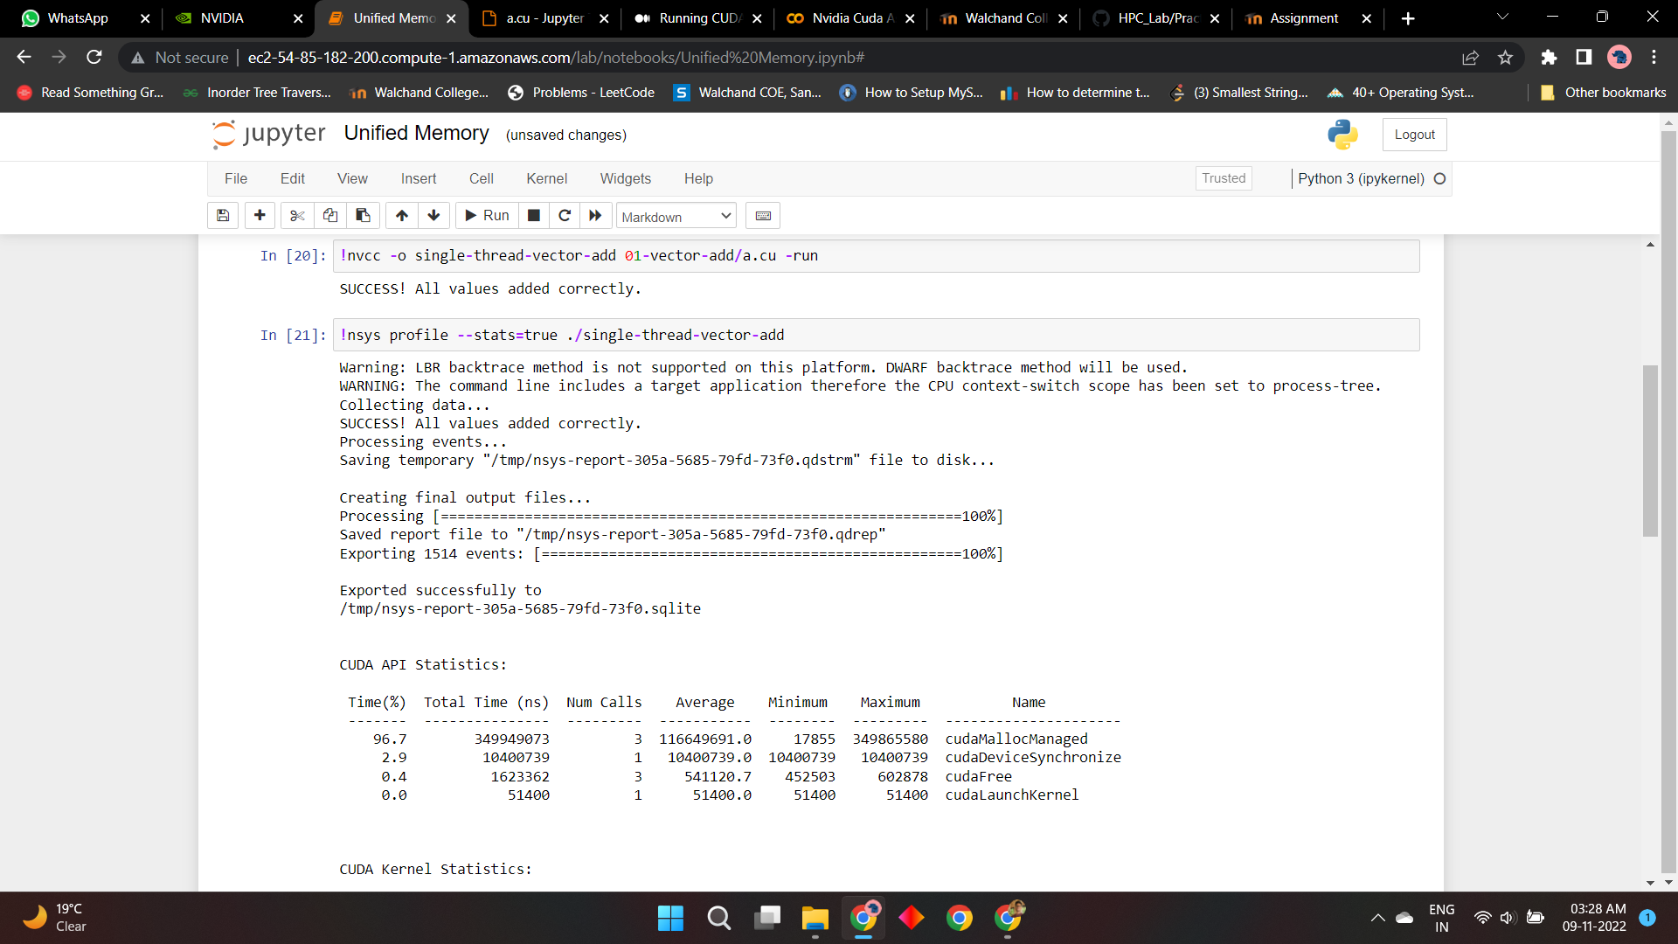

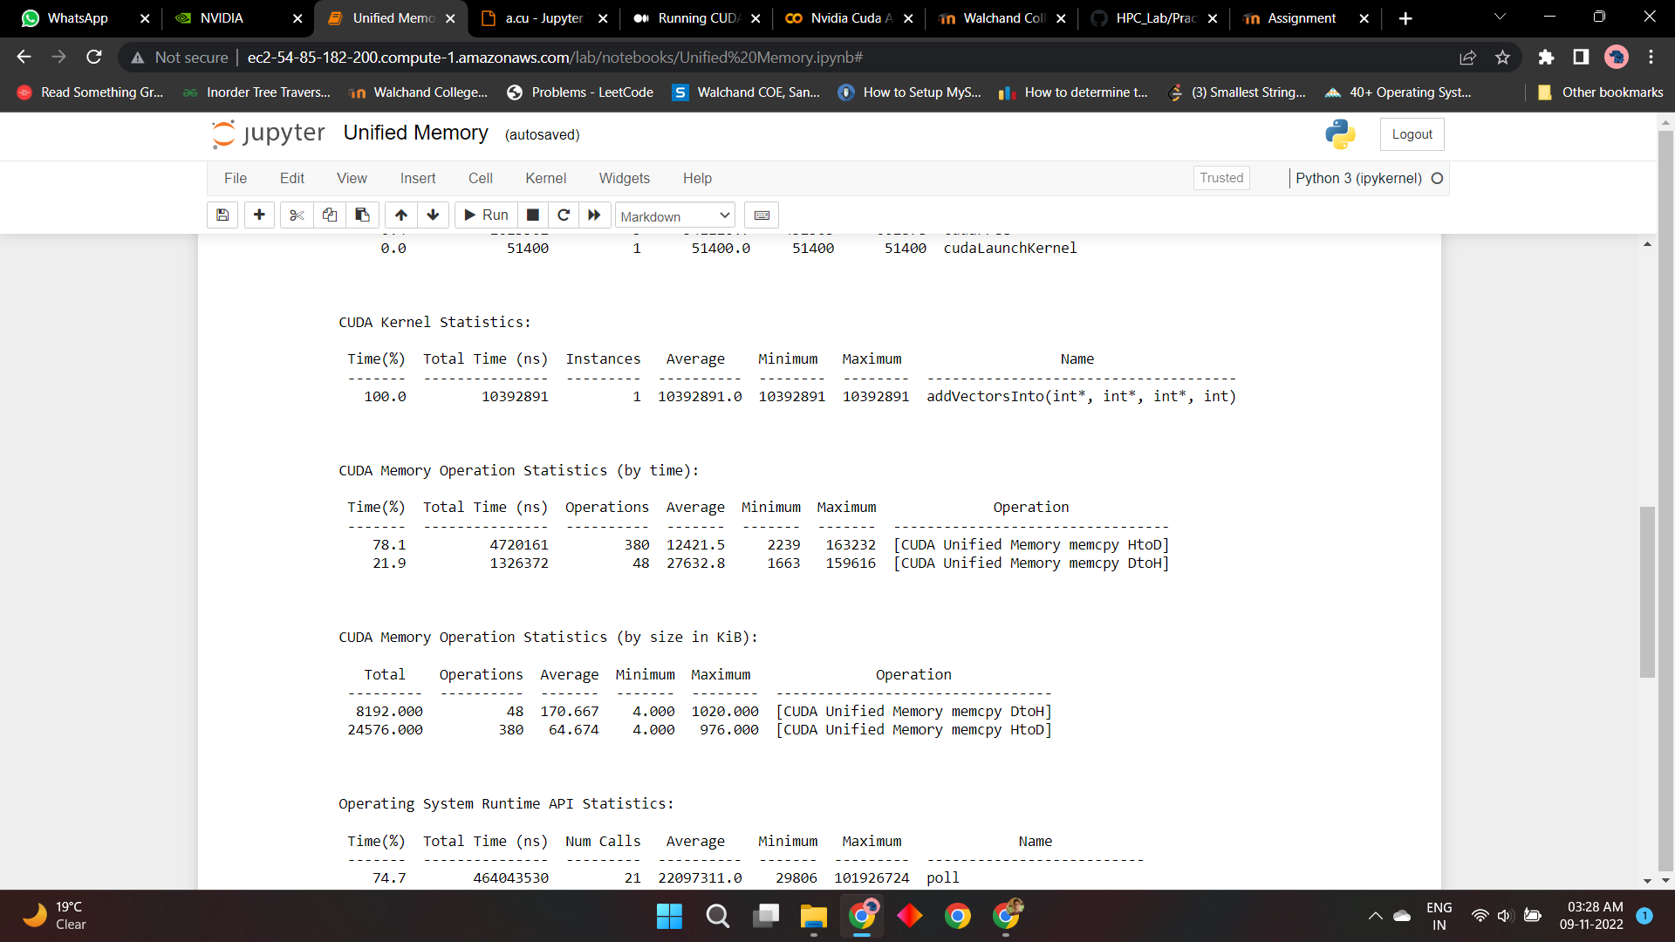

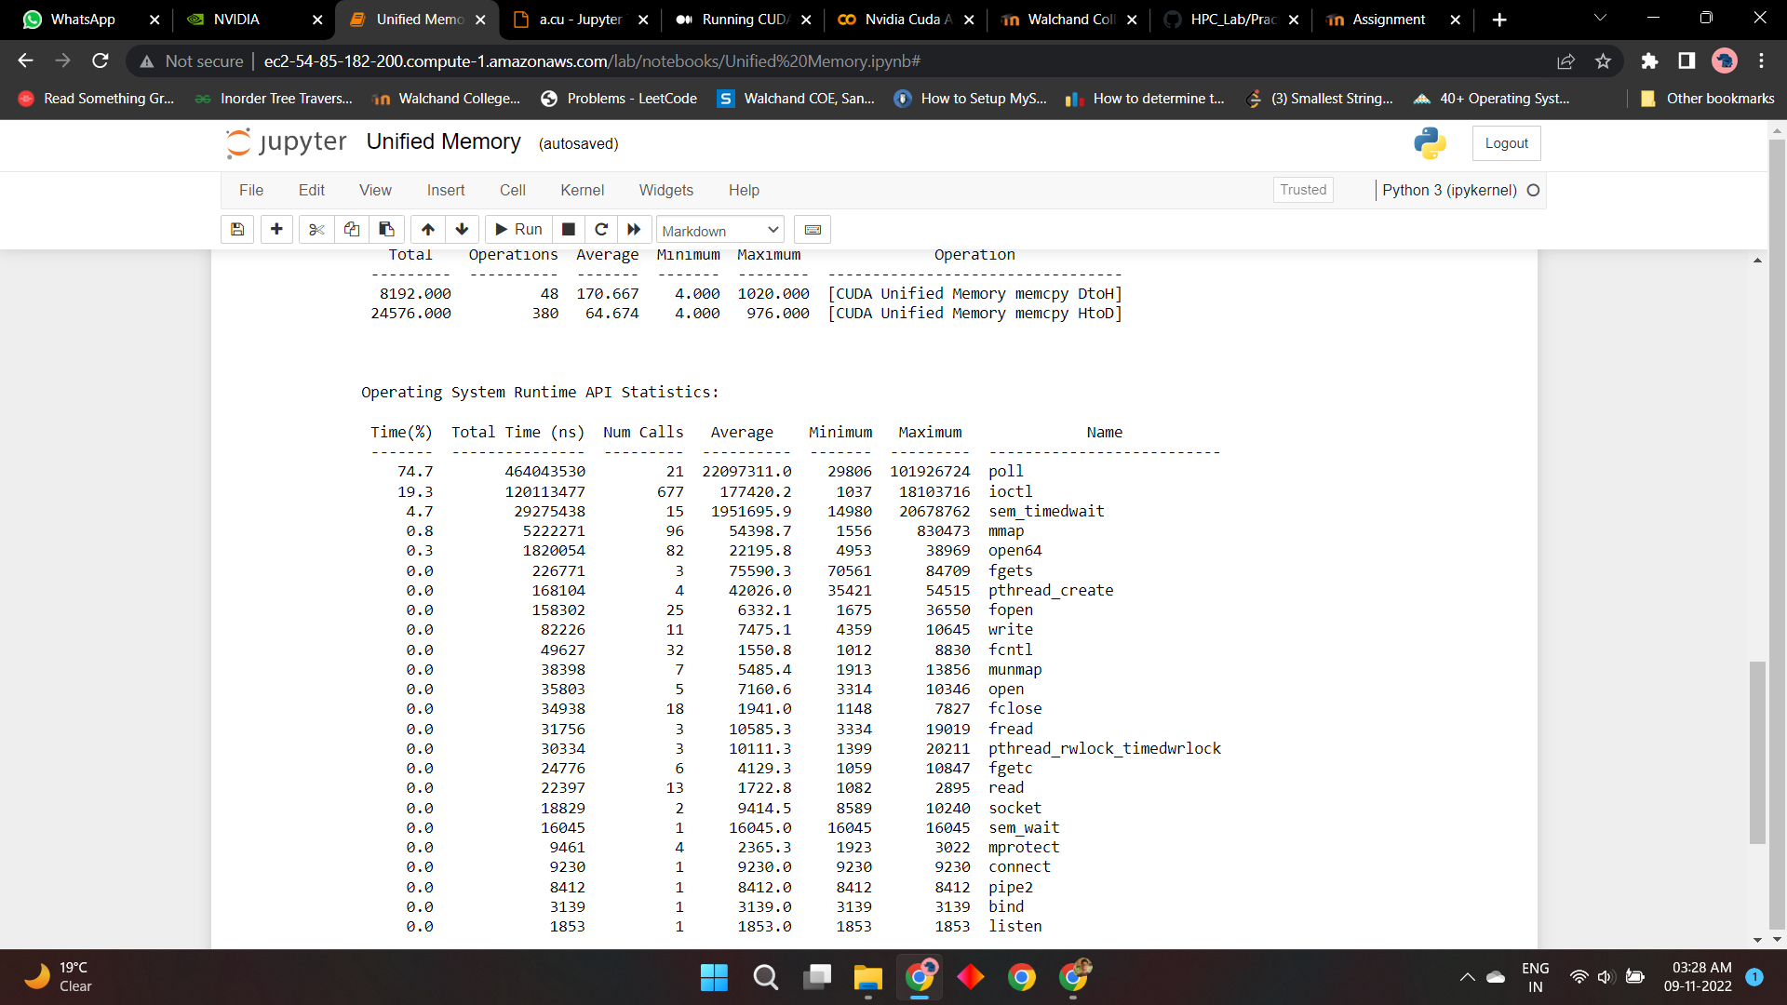

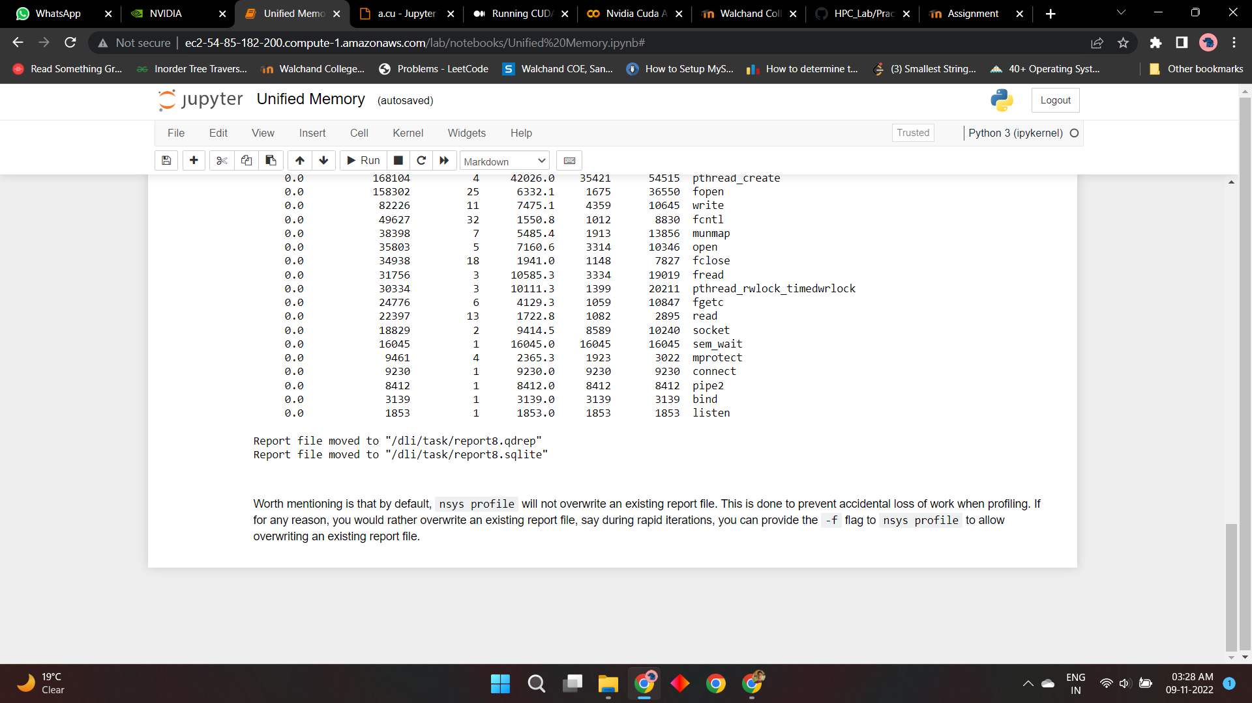

**Screenshot 3:**

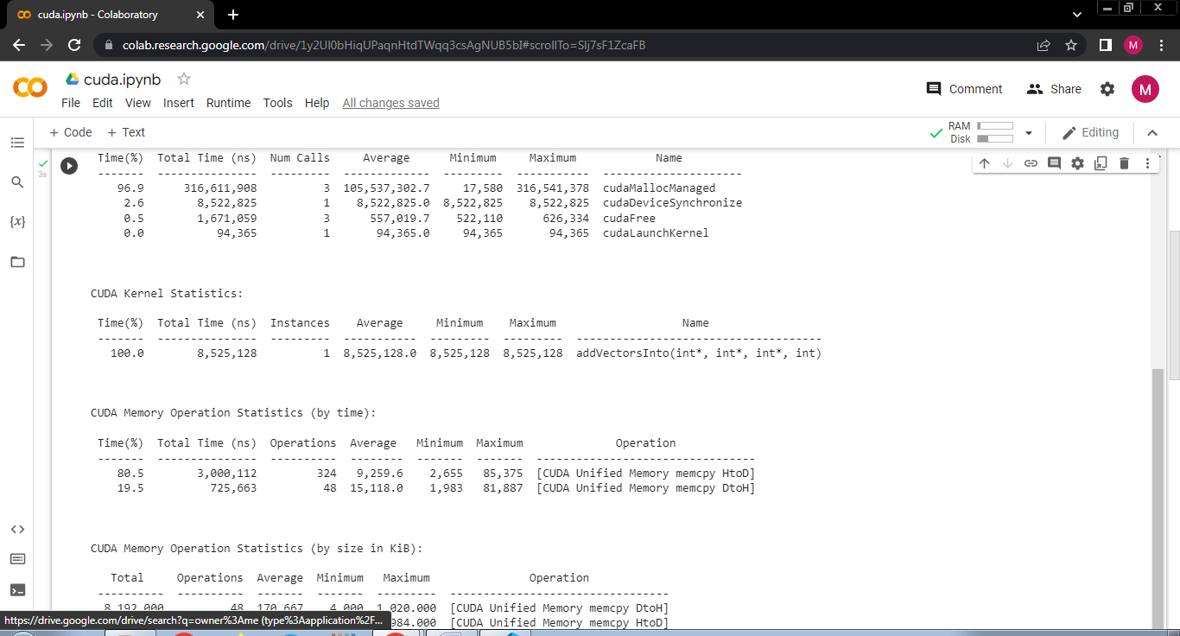

**Problem Statement 2:**

Implement N-Body Simulator using CUDA C. State and justify the speedup using different size of threads and blocks.

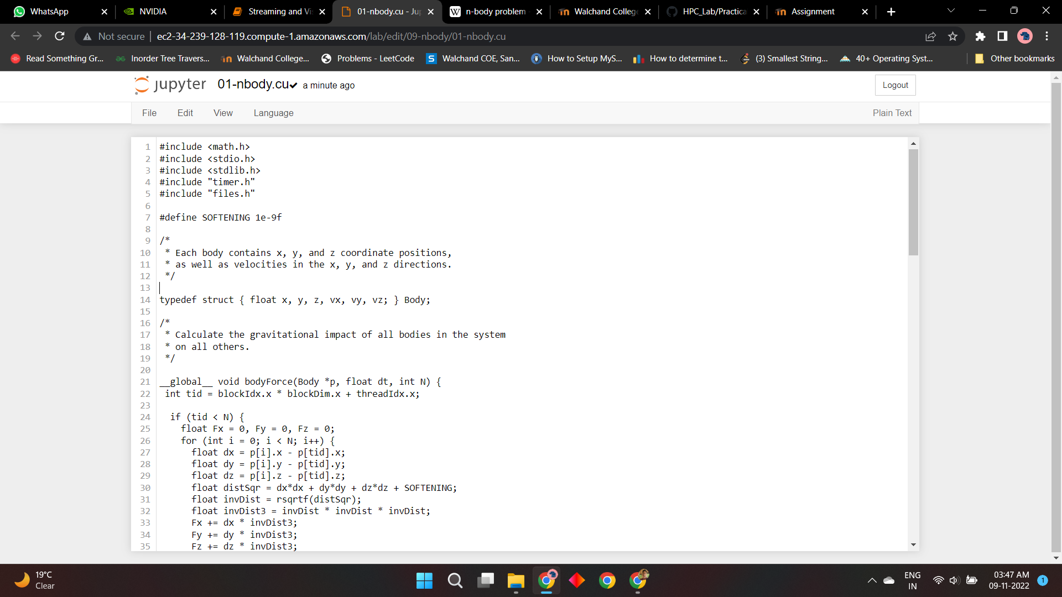

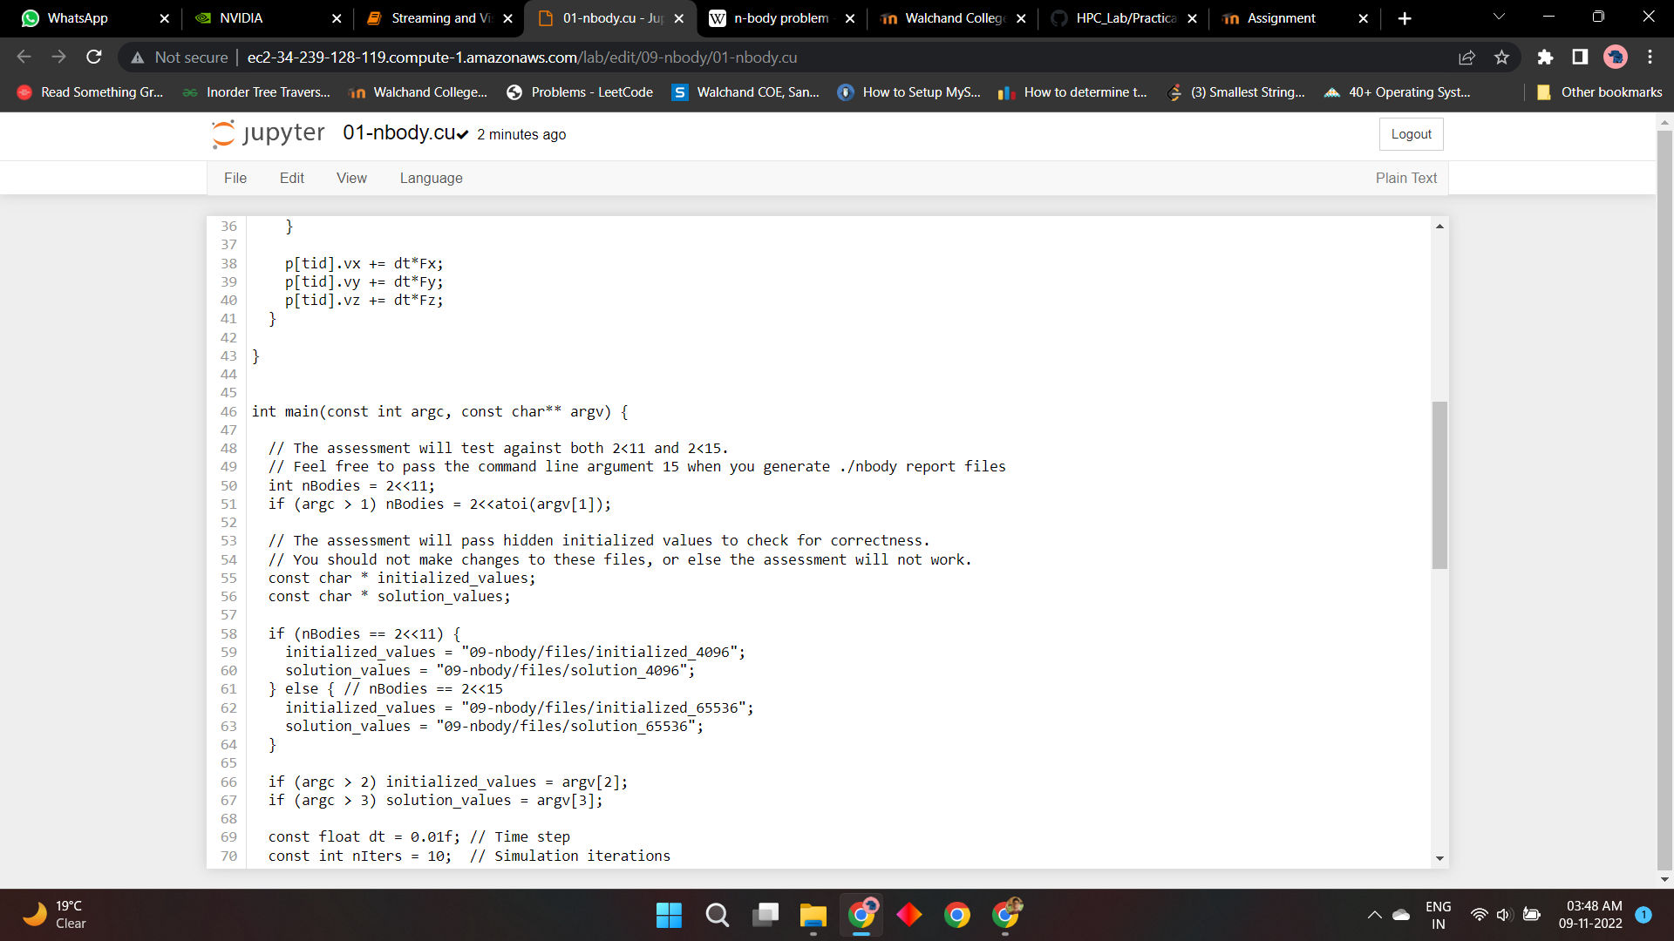

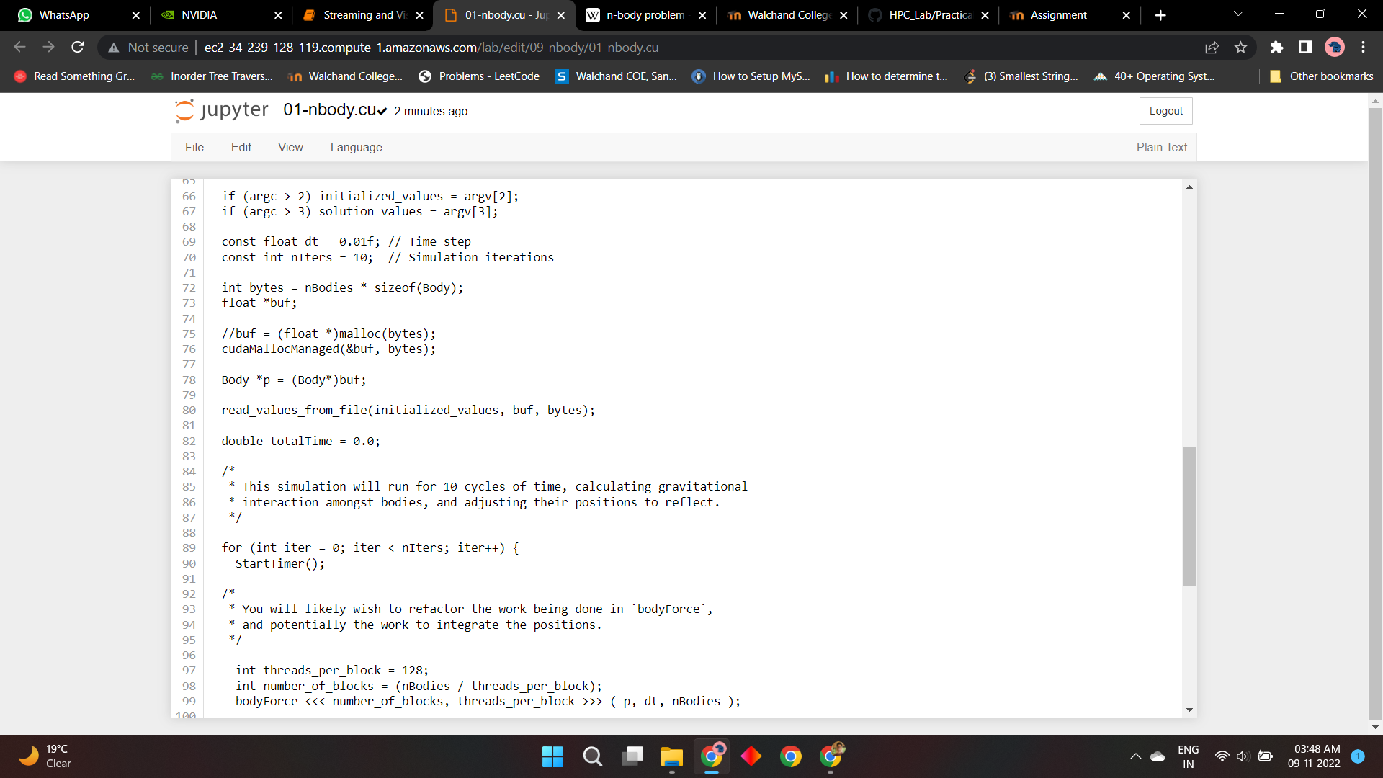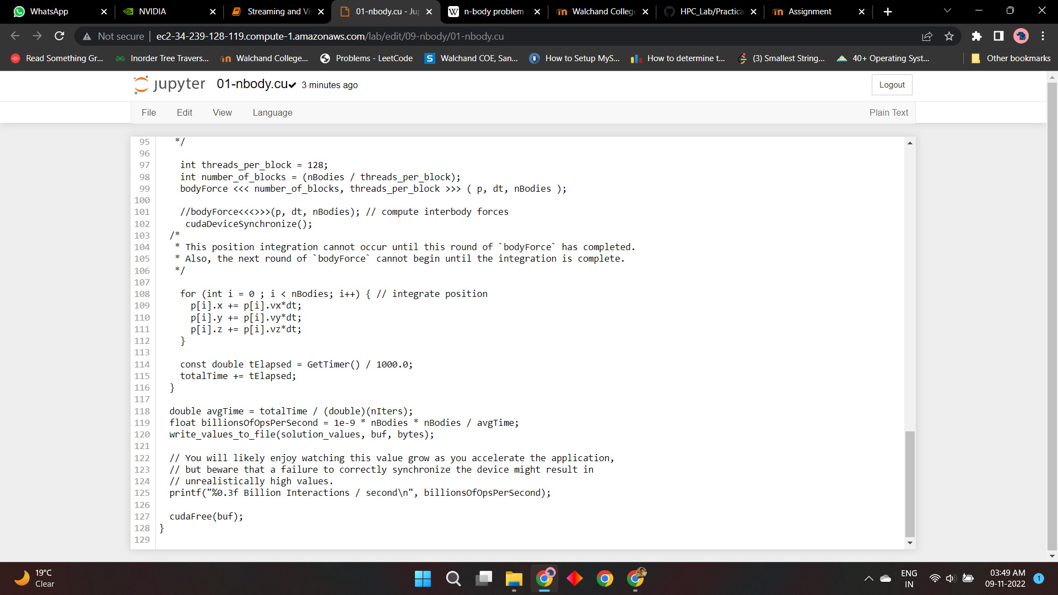

Answer:

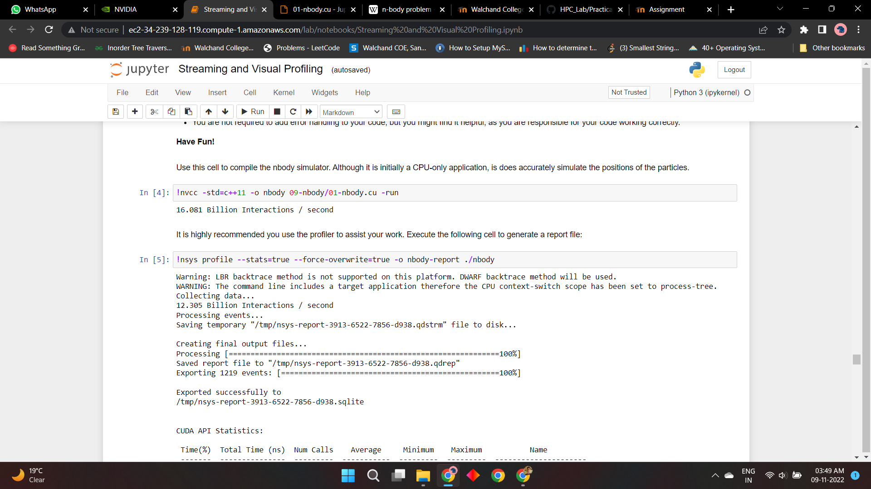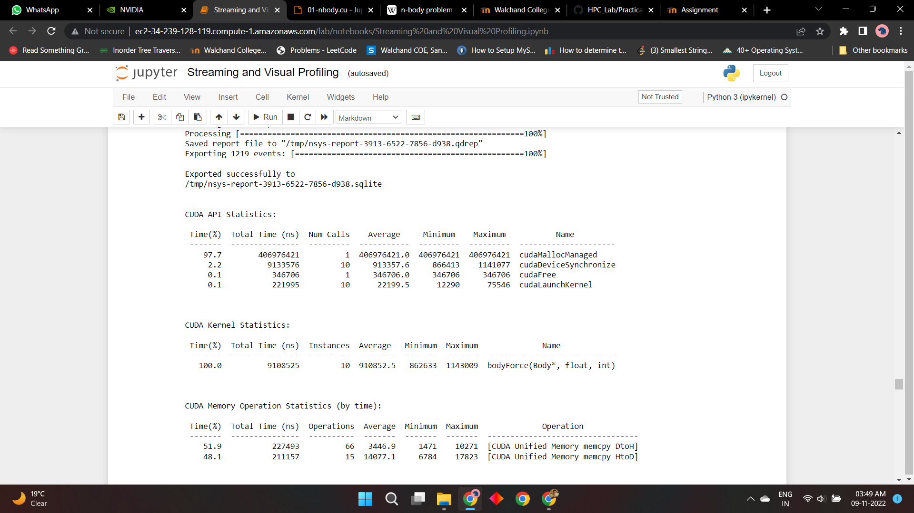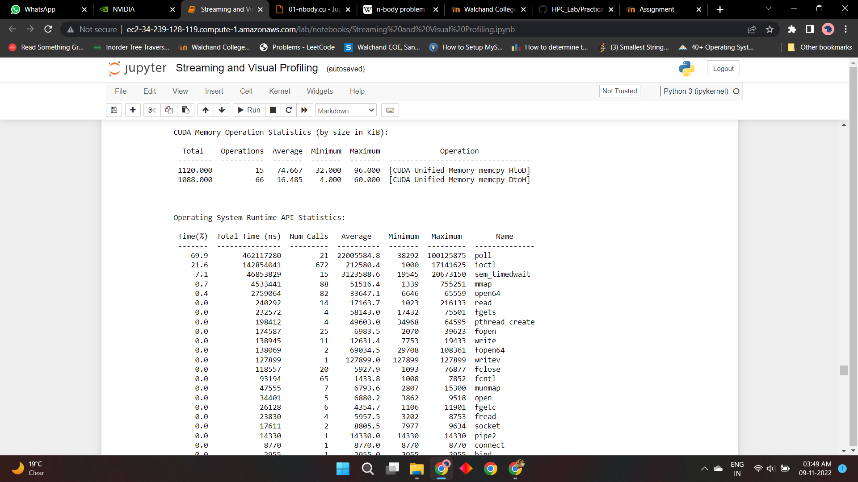

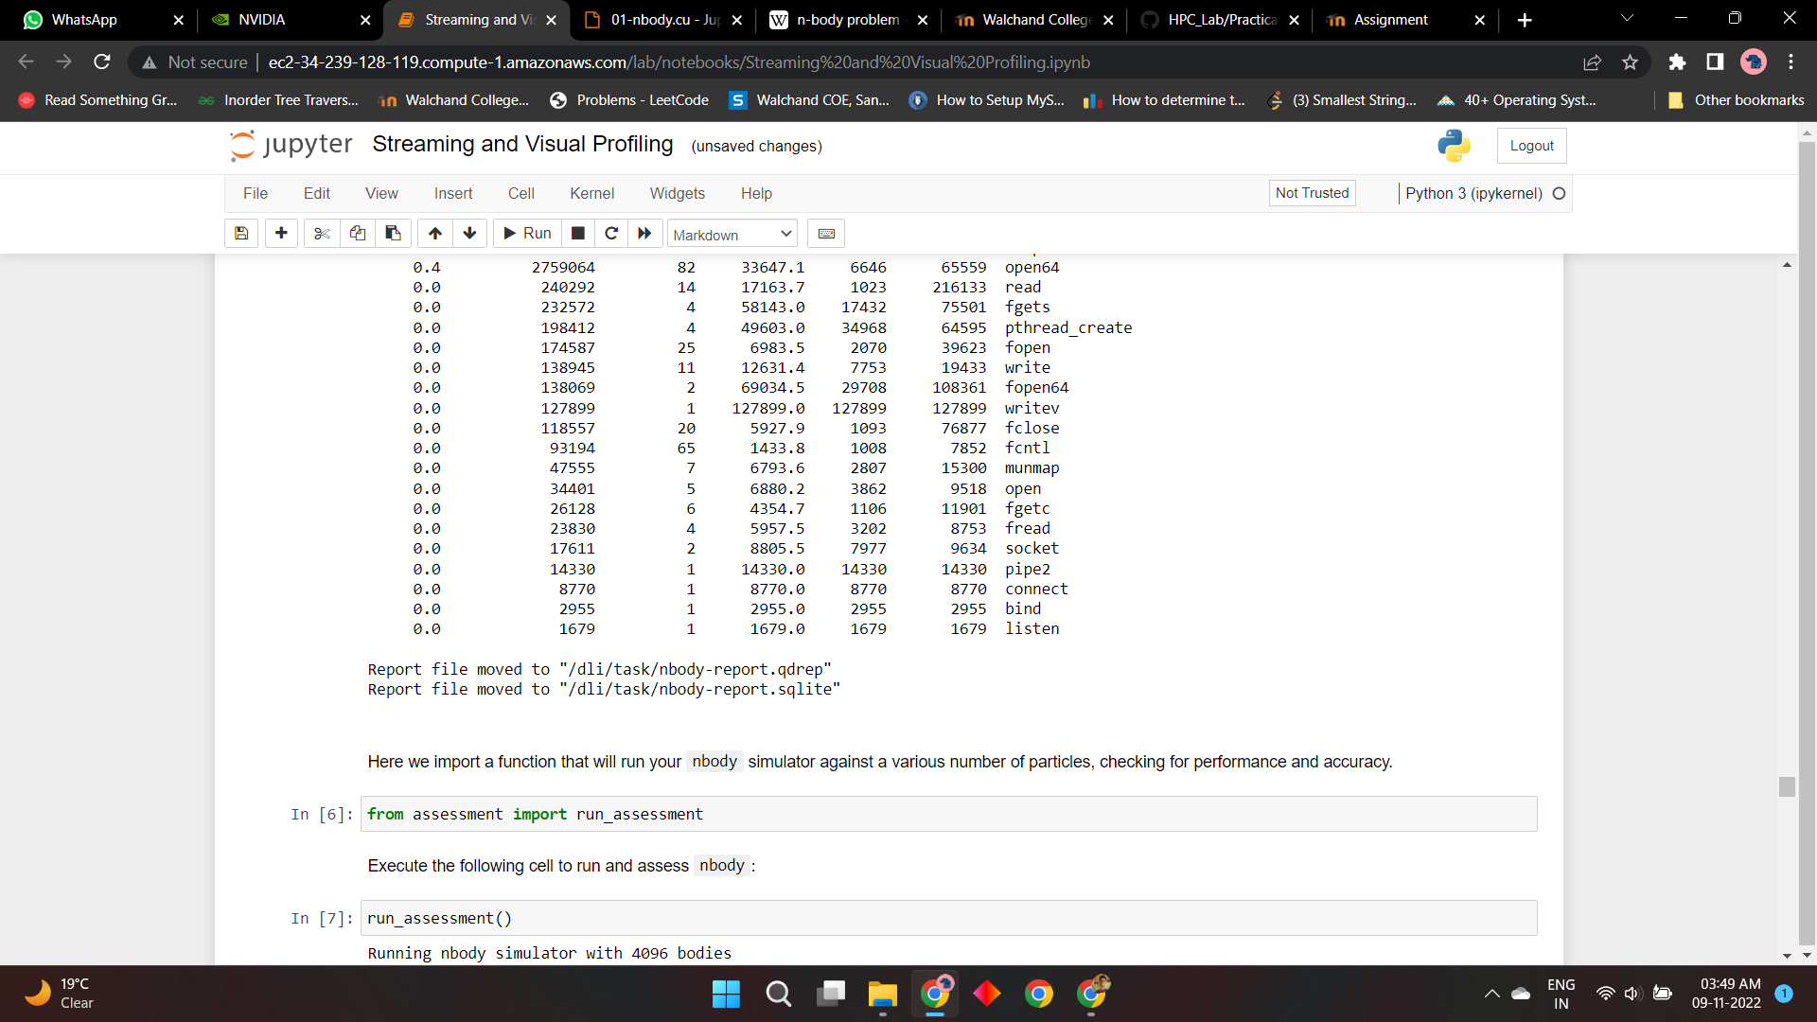

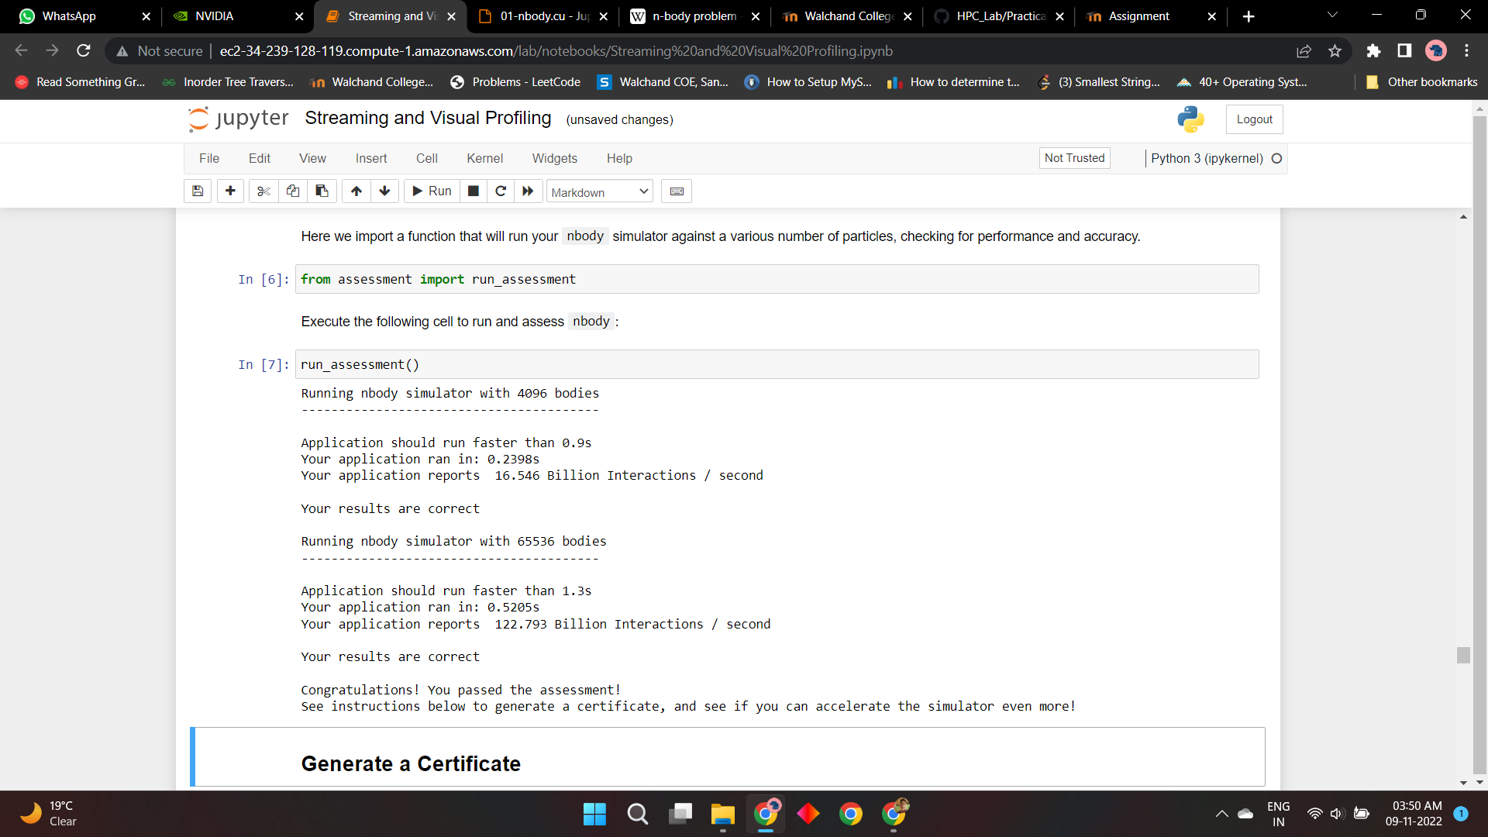

**Github Link:**

<https://github.com/OnkarGavali/HPC_Lab/tree/main/Practical_No9>